Quarterly Statistical Release
March 2008, N° 32
This release and other statistical
releases are available on efama’s
website (www.efama.org)

Trends in the European Investment Fund Industry

in the Fourth Quarter of 2007

and

Results for the Full-Year 2007

This report was prepared by Bernard Delbecque, Director of Economics and Research

EFAMA
The European Fund and Asset Management Association

Square de Meeûs, 18 - B-1050 BRUXELLES - Tel. 32-2-513.39.69 Fax: 32-2-513.26.43 - e-mail: info@efama.org

Highlights

- European investment fund assets grew by almost EUR 400 billion in 2007 to reach EUR 7,925 billion at end 2007. Total net assets of UCITS grew by 4.2% to reach EUR 6,203 billion at year-end 2007, whereas non-UCITS assets grew by 5.3% to EUR 1,723 billion. This positive development could be achieved despite net outflows from UCITS in the third and fourth quarters of 2007, which reflected heightened risk aversion among European investors.

- The high concentration of net inflows in funds domiciled in Luxembourg (EUR 188 billion) and Ireland (EUR 80 billion) highlights the success of UCITS as a global brand and the growth of the fund business in Asia.

- Money market “enhanced” and “dynamic” funds suffered from concerns about the risk exposure of these funds to asset backed securities, as investors reassessed their portfolio composition in light of the credit crisis in the second half of 2007.

- Enhanced competition from banking deposits and structured products against the background of rising interest rates continued to be felt strongly throughout Europe, with Italy being the most severely hit.

- The demand for balanced funds remained strong throughout Europe. Funds of hedge funds, especially in France, Italy and Switzerland, and special funds reserved for institutional investors, especially in Luxembourg, Germany, Denmark and the United Kingdom, recorded substantial inflows.

Outlook

- The prospect for 2008 is uncertain, as the risks surrounding financial markets and global economic growth remain on the downside. Hence, investors’ appetite for equity exposure and interest rate risk is likely to remain subdued. In parallel, money market funds should benefit from flight-to-safety effects in the first quarter of 2008.

- As regards the medium-term, unwinding of flight-to-safety portfolio shifts in response to greater investor confidence should trigger renewed demand for equity and bond funds.

- Assuming Asian economies continue to expand at a steady rate, UCITS should continue to attract strong net inflows from Asia, as investors there are still in the early phases of diversifying their savings into investment funds.

- In terms of regulation, closing the gap between UCITS and other less regulated savings products both at the point of sale and at production level, and removing the sources of inefficiencies in the UCITS Directive, would strengthen the foundations for the continued success of UCITS in the future.

- Equally important is the need to further highlight in Europe the benefits of maintaining a proportion of long-term savings in equity to optimize the return of pension savings.

The European Investment Fund Market
Main results for 2007

UCITS recorded net outflows of EUR 40 billion in the fourth quarter of 2007, compared with outflows of EUR 61 billion in the third quarter. As a result, net sales of UCITS fell from EUR 452 billion in 2006 to EUR 170 billion in 2007. The origin of this outcome lies in a combination of adverse financial market conditions – continuing stock market volatility and rising interest rates – that accelerated flight-to-safety portfolio shifts during the second half of 2007.

Despite these circumstances, which are analyzed on pages 5 and 6 of this report, total fund asset growth remained positive, boosting investment fund assets from EUR 7,552 billion at end 2006 to EUR 7,925 billion at end 2007. Total net assets of UCITS grew by 4.2% to reach EUR 6,203 billion at year-end 2007, whereas non-UCITS assets grew by 5.3% to EUR 1,723 billion.

With total assets growing by 34% on average, UCITS domiciled in Central European countries had an excellent year 2007. UCITS asset growth was also well above European average in Norway, Liechtenstein and Turkey.

Other positive trends in 2007 were: the good performance of balanced and money market funds in terms of net sales, the continued success of funds of hedge funds in France, Italy and Switzerland, and strong inflows in special funds reserved for institutional investors in Luxembourg, Germany, Denmark and the United Kingdom.

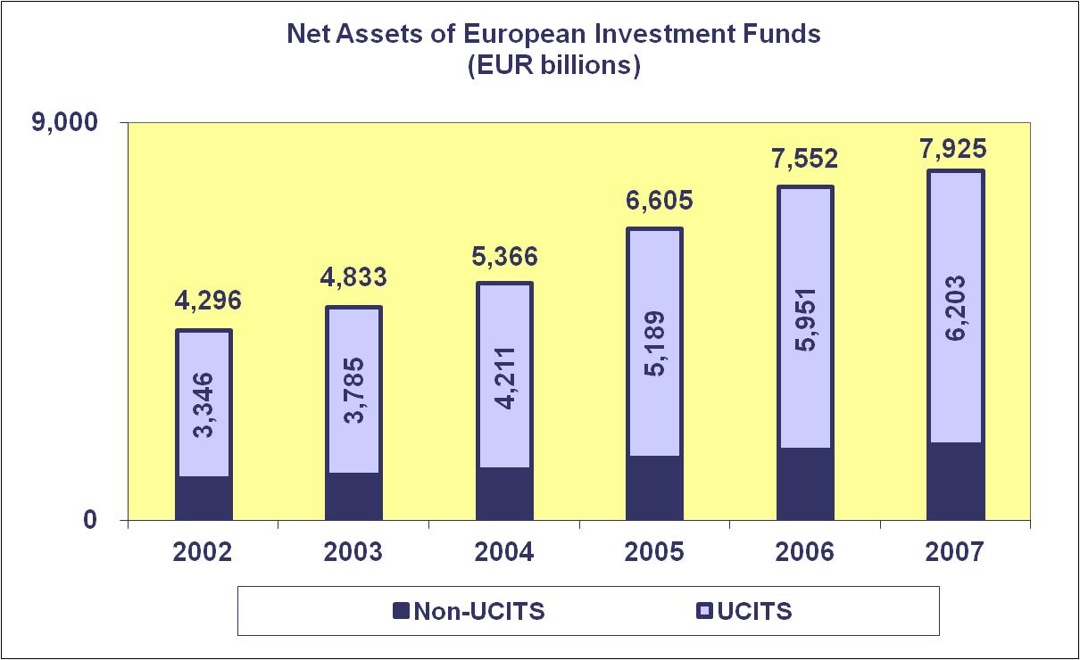

Trends in the UCITS Market
Net Sales by Investment Type

UCITS recorded net outflows of EUR 40 billion in the fourth quarter of 2007. Bond funds recorded the highest level of net outflows (EUR 32 billion), followed by equity and money market funds (EUR 25 billion and EUR 13 billion, respectively).

For the year as a whole, UCITS collected EUR 170 billion in new money. Equity and bond funds recorded net outflows of EUR 58 billion and EUR 60 billion respectively. In contrast, balanced funds continued to attract new money, albeit a slower pace than in 2006, whereas inflows into money market funds remained stable. The demand for “other” UCITS remained strong, reflecting inflows into funds of hedge funds in France and into institutional funds in Luxembourg.

Trends in the UCITS Market
Flight to safety in response to adverse financial market conditions

A striking development in the fund industry in 2007 was the shift of investor demand away from equity and bond funds. Two main set of factors relating to financial market conditions explained this outcome.

- The rise in stock market volatility to unusually high levels dampened investor demand for equity funds. As suggested on the top chart on page 6, investors started to change their perception about stock price performance in the second quarter of 2006 in response to a downward market correction, and since then, their appetite for equity investing remained subdued, despite buoyant stock markets in following quarters. Intra-quarter swings in stock prices appeared to have triggered an entrenched reassessment of equity risk, and the credit market shocks and the losses recorded by many stocks in the second half of 2007 deteriorated investor sentiment further.

- Rising interest rates in 2006 and 2007 depressed bond fund returns and thus investor demand as well, as illustrated on the bottom chart on page 6. Bond funds also suffered from two related developments: firstly, the pass-through of market interest rates to interest rates on short-term bank deposits, which increased the attractiveness of bank deposits, and secondly, the prevailing upside risks to price stability, which intensified concerns among market participants about long-term interest rates. Finally, the financial market turbulence since early August 2007 also took its toll on bond funds, as the massive downgrades of sub-prime market-related asset-backed securities and collateralised debt obligations triggered portfolio shifts away from dynamic and enhanced short-term funds.

There are similarities between investor demand for equity funds in 2007 and 2002. Following a period of enduring rising stock prices and sustained inflows into equity funds, investors reacted to downward market corrections by curtailing their net purchases of equity funds in both years, albeit more heavily in 2007. The memory of the length and strength of the bear market in 2001-2002 against the background of relatively high stock valuation and uncertainty about the global economic outlook has certainly contributed to exacerbate the search for safety in 2007.

There are also similarities between the financial market developments in 2007 and 2000, and their overall impact on the demand for bond funds. In both years, bond funds suffered from outflows in an environment of rising short and long-term interest rates. Rising spreads driven by concerns about credit and liquidity risks compounded this trend in 2007.

The key difference between 2007 and previous years is that the adverse developments on worldwide stock markets could not be offset by favourable conditions in fixed-income markets (or vice versa).

Looking forward investor demand for equity funds is unlikely to strengthen as long as the outlook of economic activity remains uncertain. Also, as long as European households will not have developed a culture saving for retirement by investing in stock markets, equity funds will continue suffering from subdued demand in periods of stock market uncertainty. The U.S. mutual fund industry tends to suffer less from short-term market developments, as many Americans use equity funds to prepare for retirement. To generate a sustained source of new money flowing into equity funds across the economic cycles, the European fund industry – and all interested stakeholders in retirement savings – should enhance their efforts to highlight the benefits of equity exposure within a diversified portfolio. As clearly highlighted in a recent report published by Oxera, on average, equity investment generates higher returns than investment in bonds, and over the longer run low rates of return during some periods are balanced by higher returns in others.

Concerning bond funds, it is likely that demand will pick up as soon as investors scale back their expectations of inflation and further rises in interest rates. The rebound is likely to benefit mostly regular bond funds to the extent that the recent turmoil in credit markets has strongly highlighted the risks related to asset-backed securities and related financial instruments.

Trends in the UCITS Market
Net Sales by Country of Domiciliation

In the fourth quarter of 2007, net sales were positive in 10 countries, with Luxembourg recording the strongest inflows (EUR 35 billion). Among the other countries, France was the most severely affected with outflows totalling EUR 51 billion. Even if outflows from money market funds at year-end have a cyclical component, they were exceptionally high last quarter, reflecting enduring competition from banks issuing debt securities. Bond and balanced funds also recorded outflows from dynamic treasury funds and absolute-return funds.

For the year as a whole, Luxembourg-domiciled funds collected EUR 188 billion, less than in 2006 (EUR 241 billion) but still remarkably more than in all other jurisdictions. Adding an estimated EUR 80 billion of net flows to Irish registered funds, cross-border funds sales represented about 160% of the total industry net inflows in 2007 ([188+80] divided by [88+80]), reflecting net outflows in a number of countries), with a portion of net sales being sourced outside Europe, reflecting buoyant demand for investment funds in Asia and the success of UCITS as a global brand.

UCITS also recorded positive inflows in the Nordic and Central European countries, with Norway recording the strongest total net inflows in 2007 (EUR 5 billion) – the third best performance in terms of net sales – thanks to high net acquisition of equity, bond and especially money market funds by institutional investors. The United Kingdom also enjoyed positive net sales; however, investors significantly re-evaluated their portfolio in the last two months of 2007, as the impact of the credit crunch began to be felt.

With the exception of Liechtenstein, all other countries suffered net outflows. Concerning Italy, net sales of round-trip funds also turned negative in 2007 (EUR 3.1 billion), whereas funds promoted by foreign companies continued to attract new money (EUR 3.6 billion), albeit significantly less than in 2006 (EUR 21.3 billion). On the positive side, net sales of non-UCITS (mostly hedge funds) remained strong in 2007 (EUR 6.9 billion, compared to EUR 5.3 billion in 2006). In Germany, net inflows into “round-trip” funds domiciled in Luxembourg totalled EUR 47.5 billion in 2007 (EUR 28.7 billion benefiting money market funds and EUR 19.4 billion guaranteed and other funds using derivatives). Hence, taking into account net inflows in “round-trip” funds, German investors contributed EUR 34 billion in 2007, 40% more than in 2006 (EUR 24 billion).

Trends in the UCITS Market
Net Assets by Investment Type

Total net assets of UCITS fell by 2.0% in the fourth quarter to reach EUR 6,203 billion at end December 2007.

Total assets in UCITS rose by 4.2% in 2007, compared to 14.7% in 2006. UCITS assets growth was positive for all fund categories, except for bond funds. “Other” UCITS enjoyed the strongest growth, followed by balanced funds, money market funds and funds of funds.

Equity and balanced funds combined accounted for 55% of all UCITS at end 2007, compared with 56% one year before.

Trends in the UCITS Market
Net Assets by Country of Domiciliation

Looking at developments in the UCITS market in the leading countries, the United Kingdom, Ireland and Luxembourg recorded the highest asset growth in 2007, 12.0%, 10.9% and 9.8%, respectively. Whilst significantly lower than in 2006, these growth rates appear excellent in light of the developments in the other countries. Whereas France just managed to avoid a fall in total UCITS assets, Germany, Spain and Italy suffered negative asset growth. The drain on assets was particularly strong in Italy, reflecting large outflows from all fund categories except money market funds. Portugal and Greece also recorded similar portfolio shifts away from UCITS.

Asset growth was well above the European average in 2007 in Central Europe, with UCITS assets growing by 34% on average. In both percentage and absolute terms, growth was particularly striking in Poland, bringing UCITS assets above the EUR 30 billion threshold. In the Nordic countries, Norway also enjoyed a sharp increase in assets (from EUR 41 billion to more than EUR 52 billion), as well as Liechtenstein and Turkey.

Elsewhere in Europe, asset growth turned negative in 2007.

Trends in the Non-UCITS Market
Net Sales and Assets by Investment Type

There was hardly any change in total assets of non-UCITS in the fourth quarter. Compared with end 2006, total net assets increased by 5.3% in 2007, to EUR 1,723 billion.

During the fourth quarter, net flows to special funds reserved for institutional investors collected EUR 30 billion in new investment, one of the highest levels of inflows in recent years. This reflected a sharp rebound in net flows into German “Spezialfonds” to EUR 13 billion (from EUR 21 million in the previous quarter) and Luxembourg-domiciled funds to EUR 17 billion (from EUR 13 billion in the previous quarter). For the year as a whole, special funds collected EUR 76 billion in new money, EUR 8 billion more than in 2006, with Luxembourg enjoying the strongest inflows (EUR 38 billion), followed by Germany (EUR 27 billion), Denmark (EUR 6 billion) and the United Kingdom (EUR 4 billion).

Assets in real estate funds grew 5.3% in 2007, reflecting in part total net inflows of EUR 6.4 billion in Germany. Real estate fund assets increased in all other countries, except in Belgium, Hungary, the Netherlands and the United Kingdom (where a reclassification of funds into Property UCITS explained the decrease in net assets).

It is also worth noting the continuing rise in Luxembourg-domiciled “other” funds, and in “other” non-UCITS reflecting significant asset increase in alternative management funds in Italy (EUR 6.8 billion) and Switzerland (EUR 8.7 billion) and venture capital in France (EUR 4.5 billion).

Trends in the European Investment Fund Industry
Net Assets by Country of Domiciliation

The combined assets of the investment fund market in Europe, i.e. the market for UCITS and non-UCITS, fell by 1.6% in the fourth quarter to reach EUR 7,925 billion at end 2007. Compared with end 2006, total net assets increased by 4.9% or EUR 373 billion.

Five countries finished the year with a market share greater than 10%: Luxembourg (26.0%), France (19.0%), Germany (13.1%), Ireland (10.2%) and the United Kingdom (10.1%).

With EUR 6,203 billion invested in UCITS, this segment of the business accounted for 78.3% of the fund market at end 2007.

“UCITS” is used in this note in the sense of publicly offered open-end funds investing in transferable securities and money market funds, whereas the “non-UCITS” part of the investment fund market groups funds that are regulated in accordance with specific national requirements.
See the report published by Oxera “Defined-contribution pension schemes : Risks and advantages for occupational retirement provision”, which can be downloaded from the EFAMA website.
Our statistics include for the first time data for Romania and Slovenia.

